Proposed re-development of the Convent site at
Sean McDermott Street Lower, Dublin 1
0.82 hectares (2.04 acres)

The Development site in a City Context

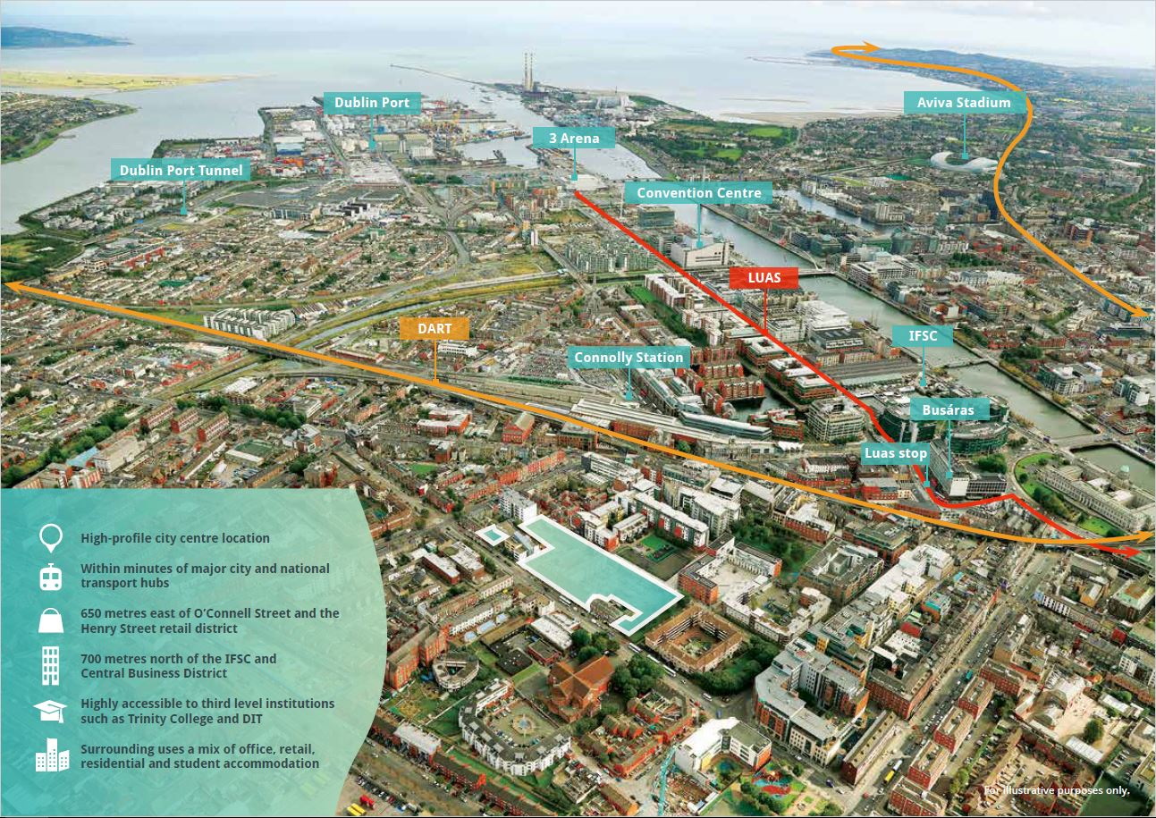

Development site outlined in red

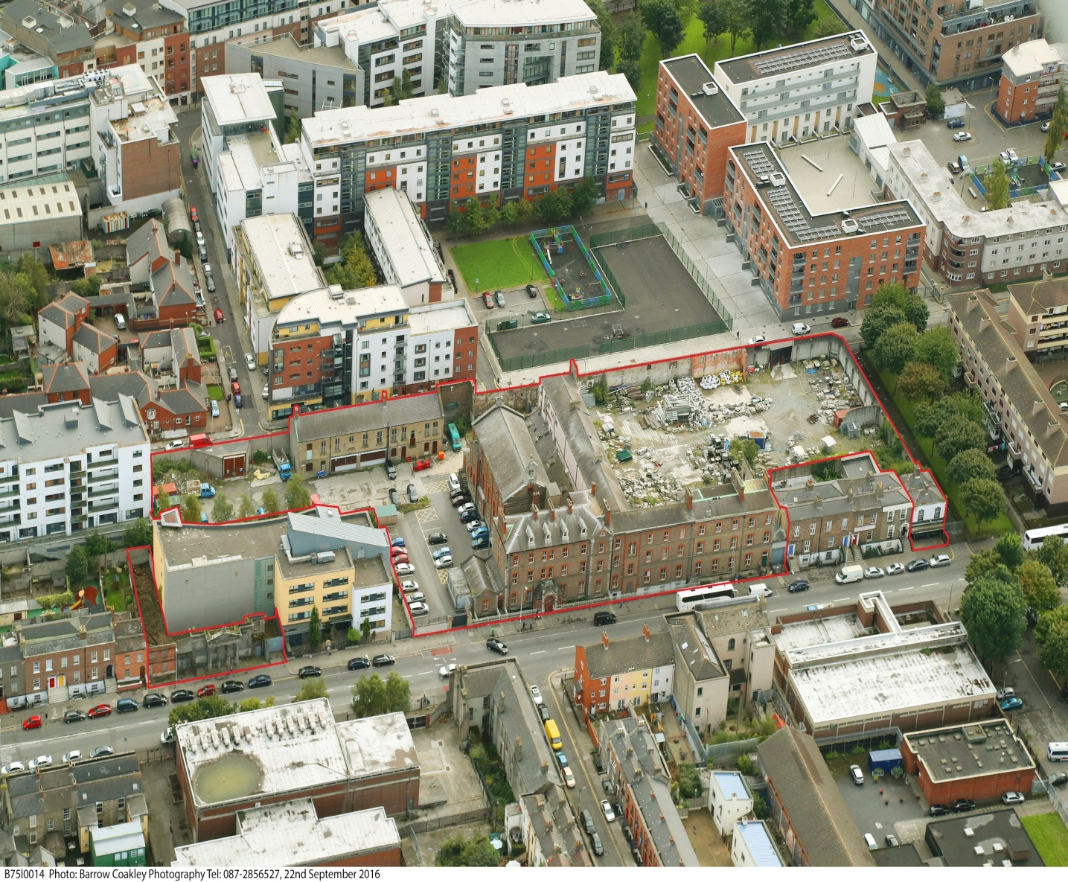

Overview:

This site is in Dublin City Council ownership and represents one of the most significant development sites in the North East Inner City outside of the Docklands. It is a key strategic location in the centre of Sean McDermott Street, has great potential to create a landmark mixed development, and act as a strong catalyst for badly needed economic and physical regeneration of this street and its environs which is only a few hundred yards away from O Connell Street.
It is now proposed to dispose of this property following a public marketing process to a Japanese Hotel Company who already have property interests in this Country.

The Developer/Preferred Bidder:
The preferred bidder is a company called Toyoko Inn Dublin, Ltd which was founded in 1986 and they expanded rapidly throughout the world from the 1990’s.

In 2007 they took a decision to expand their operation to Europe with the ambition of becoming one of the largest hotel operators in the world. The IDA and the Irish Embassy in Tokyo strongly encouraged the company to locate their Europe Head quarters in Dublin and as a result Toyoko Inn International was established in Dublin. It has close to 300 hotels globally with 100 more planned and it currently employs nearly 11,000 staff. The company has a strong policy of employing women including for all of its senior management positions. While it is known as a no frills hotel chain it has a strong record for efficiency and quality and they build well designed and modern looking hotel premises.

The Toyoko Inn brand will greatly increase visitor numbers who would not otherwise come to Ireland. Toyoko Inn has over 4 million loyalty card members and Dublin will become a desired location for many members who will travel to Europe. As Toyoko’s European Headquarters is here they strongly feel that they should have at least one Toyoko Inn Hotel in Dublin.

Toyoko believe that its hotels are a proven catalyst for future investment and business activity and from experience community safety and upkeep of the environment is greatly enhanced in the areas where their hotels are located.

The Sean Mac Dermott site is a good fit for Toyoko. It is centrally located, close to good public transport (Amien Street Station and Luas Cross City) and has the capacity to accommodate a hotel of circa 350 /400 rooms. Toyoko also considered that Dublin City Council‘s remit for a large scale supermarket can greatly improve the economic vitality of the area and the development itself.

Details of Proposed Development (subject to Planning Permission): The Purchase price offered is €14,500,000 (14.5 Million Euro):

- Hotel comprising c.350 bed rooms and ancillary accommodation (restaurants, bar, meeting room/conference facilities) = 8,300 Square Metres.

- Commercial/ Retail/Café at Ground Floor and 10 x Residential Units - over Former Convent
- Gallery/Exhibition/Event Centre/ Concert Hall - Chapel Conversion:
- Community Centre c.200 Square metres (Rear of Portico) and 6 x 1 bedroom apartments *
- Supermarket - c.1,800 Square Metres.
- Residential Accommodation - c. 140 Studio Apartments
- Auxiliary car-parking and bicycle parking*

As part of the proposed Development Agreement the Developer will provide the following
(set out below) for the City Council and transfer title to the City Council for no
financial consideration and no VAT liability:

6 no. 1 bed apartments

The 6 one bed apartments are to replace the current residential units licensed to Cunamh Teoranta. These units are occupied by the Selesian Fathers that oversee the Crinan Youth Project and provide the Parish Duties for the Archdiocese.

A community facility extending to a minimum of 200 Square metres.
The Community Centre is to provide a new base for the Crinan Youth Project that is already housed on site. This is also licensed as part of the Cunamh Teoranta portfolio

34 no. car-parking spaces including 1 parking space suitable for a minibus
6 spaces provided for the Sisters of Charity – They currently hold a 999 lease for 6 spaces on the site.
- 4 spaces for Salesians/Crinan Project as per licence to Cunamh Teoranta.
- 24 spaces for use by Dublin City Council.
- 10 no. bicycle spaces.

The potential cost of providing the above accommodation would be in excess of €1,700,000

The bidding Process – 1st Round Selection

11 Companies submitted proposals, and these were reviewed by an assessment panel consisting of the Deputy Planner, a Senior Architect, a Senior Valuer, Senior Officials from the Local Area Office, and from the Council’s Development Department.

On review, 6 parties were shortlisted to continue to the next round in the bidding process.

5 applicants failed to be selected to continue to the next round for a variety of reasons, some of which were:

- Did not meet the minimum requirements of the sales process (Invalid submission)
- Poor submissions/ Lacking detail
- Low financial offer
- Limited design detail
- No funding information
- Overly dense proposals
- No phasing detailing
- Lacking in development mix

2nd Round Proposals from the unsuccessful applicants

The unsuccessful proposals consisted of a variety of mixed use elements which included a combination of one or more of the following:
- Business and Tourist Hostel
- Hotel
- Residential Units
- Neighbourhood Shop
- Retail/Leisure
- Community Space
- Café //Shared Workspace

% Marks assigned to assess each criteria

Marking Scheme: Purchase Price 35% - Financial consideration

Design of Final Scheme 25%- Design and mix of uses

Capability to deliver 25%- Financial standing, design and
Professional team

Track Record 15%- History of Delivery

- Purchase Price: The purchase price offered (net), taking account of the cost of delivering Dublin City Council’s accommodation requirements.

- Design of Proposed Scheme: Outline design proposals together with a schedule of accommodation and phasing.

- Capability to Deliver : The parties were required to provide details on how the purchase and the construction of the proposed scheme was to be funded, with details of third party debt and equity funding if required. Details of the design and professional team involved in the delivery of the development were to be provided in order to assess their capability.

- Track Record: The history of delivery by the proposer and his team of similar mixed use urban regeneration schemes in the Irish and International market place.

Marking and ranking of 4 proposals submitted to final round:

Party | Purchase Price | Design | Capability | Track Record
1 | 1st | Joint 1st | Joint 1st | Joint 1st
2 | 3rd | 2nd | Joint 1st | Joint 1st
3 | 2nd | 3rd | 3rd | 3rd
4 | 4th | Joint 1st | 2nd | 2nd

Memorial for the Magdalene home:
We are very conscious of the history of this property/site (The Laundry part of the premises was demolished in 2005 following a fire) and the controversial role also played by the Magdalene Homes at other locations throughout the country.
It is very appropriate that a suitable permanent memorial be included in any proposed redevelopment of this property/site.
Therefore there will be a specific condition in the Development Agreement with Toyoko for the provision of such a memorial in the proposed development.

We are happy to meet the relevant Magdalene Survivor Groups over the coming weeks to discuss the provision of this memorial and to work with them on design etc.

We recently commissioned a detailed archaeological survey of the site which uncovered no evidence of any burials, however all stages of construction on the site will be monitored by a Grade 1 Conservationist.

Why not develop the site for Social Housing?:

Of couse there is an argument for the development of the site for Social Housing in light of the Housing Crisis, however this immediate area already has one of the highest concentrations of social housing in the whole country with several apartment complexes nearby such as Killarney Court (Formerly St Joseph’s Mansions) St Mary’s Mansions, Liberty House, Gardiner Street Flats as well as a large number of Social Houses.

In addition there are two hostels immediately adjacent (Dublin Simon and Sophia) and there are plans for new social housing at nearby Railway Street.

Going forward we do hope to develop further social and also affordable housing in this general area on other sites. It is also essential that more private housing gets developed in this area over the coming few years.

We are strongly of the view that the strategic position of the Convent site merits an economic regenerative solution which will benefit the whole area in terms of footfall, jobs and act as a catalyst for further physical redevelopment in the area rather than the provision of further social housing.

Economic Benefits of the proposed Development:

Employment potential
- Hotel – approx. 100 permanent and temporary staff.
- Retail and student accommodation – 60 to 75 staff.
- Construction Jobs – 500 staff - Local employment charter.
The Central Area Office and the NEIC Implementation Board (Following on from the Taoiseach’s Special Taskforce) are working in partnership to develop new streams of training to equip local people with the necessary skills to take up employment in emerging roles that are being created by employers in the area.
The potential of a new hotel in the existing Convent lands will provide an ideal employment opportunity for local people appropriately trained to apply for the various roles required to operate a successful hotel.
The Kieran Mulvey Report arising from the above mentioned Task Force made reference to the strong long term potential of some key redevelopment opportunities in the North Inner City Area including this particular site. We believe this is a powerful opportunity and really a chance of a lifetime for the Sean McDermott area.
Dublin City Council uses the proceeds from such property sales to invest in other infrastructural projects throughout the city including in the North East Inner City Area
A decision by this Local Authority to dispose or not to dispose of land/property is a function reserved for Dublin City Councillors and we intend to bring forward this disposal to a meeting of the City Council in the future. In the meantime we will continue our ongoing discussions/negotiations with the Preferred Bidder.
Management is strongly recommending that this powerful redevelopment opportunity for Sean McDermott be taken and for the proposed disposal to be agreed.

Brendan Kenny Deputy Chief Executive 16th March 2018

