Convent Lands Survey Results March 2018
Should our local Councillors vote to sell the land to Tokoyo Hotels for development of the site?
Yes 15.89%
No 84.11%
N

- ICON developed a simple survey which was distributed via survey monkey to a range of mailing lists and posted on Facebook. People were encouraged to share it. It was sent via post with stamp addressed envelopes to the residents on the ICON mailing list. ICON met with community and tenant’s groups and volunteers took surveys to complete with their family and neighbours.
- ICON received 223 responses in total, it should be noted that this is a sample of those within the community who are motivated to respond, they self-declared their interest. We did not have the resources to go door to door.
- The survey had four main questions and room for comments. The first question asked people their views on the proposed plans for the Convent Lands Site by rating how they felt about each individual item, the ratings went from terrible to great with a no opinion option. The second question asked for views on the ideas that were discussed at the first Public Meeting in January, respondents were again asked to rate their views. The third question was open ended and asked people for their ideas for the site and the fourth question asked respondents if the Councillors should vote to sell the land to Tokyo Inn Hotels.
- The survey also allowed respondents the opportunity to comment further on their answers. The comments are included at the end of this document.

Qs. 1 What do you think of the following plans for the Convent Site?
Hotel with 350 bedrooms and additional accommodation, restaurant/bars, meeting rooms and conference facilities
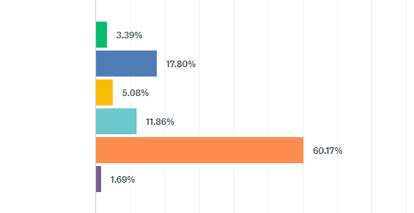
- 60% of respondents felt that a hotel was a terrible idea and 12% felt it was poor, resulting in an unfavourable rate of 72%.
- 18% felt that it was a good idea and 3% felt it was great, resulting in a positive rate of 21% overall.

Commerical/ retail/café at ground floor

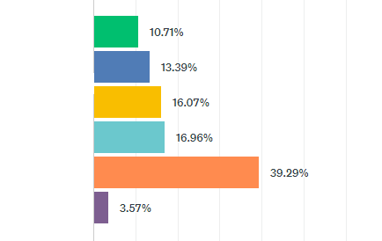
- 39% of respondents felt that the commerical/retail/café at ground floor level was a terrible idea and 17% felt that it was poor, resulting in an unfavourable rate of 56%.
- 13% stated that it was a good idea and 11% said that it was great, an overall positive response rate of 24%.

Gallery/Exhibition/Event Centre/Concert Hall

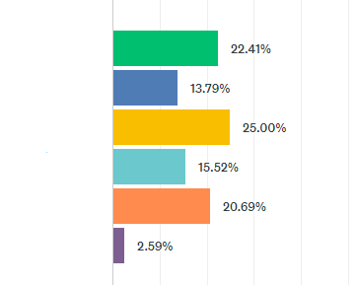

- There was a mix of views in with 21% declaring the idea as terrible, 16% as poor but 14% felt it was good and 22% stated it was great.
Community Centre- new base for the Crinan Youth Project
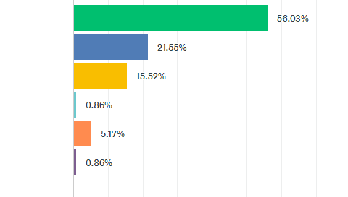

- 56% of respondents stated that a new centre for the Crinan Youth Project was a great idea and 22% felt it was a good idea, resulting in 78% overall in favour with only 6% against the proposal.

Supermarket 1,800 square meters
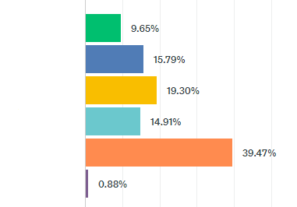
- 39% of respondents thought it was a terrible idea and 15% felt a supermarket was a poor idea, resulting in 54% looking unfavourably on the proposal. 25% reacted favourably and 19% felt that it was okay.
Student Accommodation
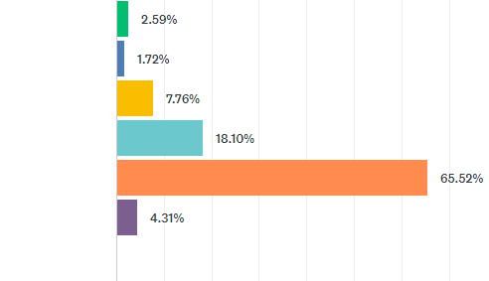
- 66% of respondents felt that the plan for student accommodation was terrible and a further 18% stating the idea was poor. 6% felt it was a great idea and 3% felt it was good.
- At the first Public Meeting we held there was a strong feeling from the floor that there should be no more student accommodation built in the area and this feeling is reflected in the surveys.
Comments
- Please no more student accommodation - it's everywhere, we need homes
- We need less business, less student accommodation and more social housing
- Priority stays in Public Ownership - Housing a priority. Enough Private student accommodation around.

10 Residential Units (6 for the Salesian Fathers and 4 social housing)
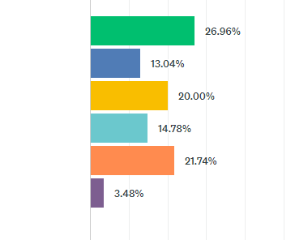
- There were mixed views in response to the proposal for 10 residential units with 37% viewing it unfavourably and 40% favourably.

Car Parking | Bicycle Parking
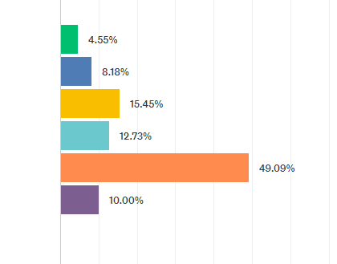 | 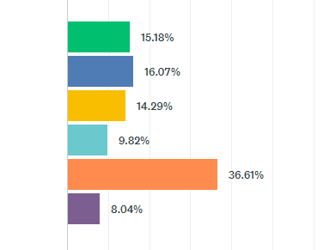
- 49% stated this was a terrible proposal and 5% were in favour, an additional 13% stated it was poor and 8% that it was good.  - There was a high no opinion response in comparison with other proposals. | - 15% thought bicycle parking was a great idea; 16% felt it was good and 37% stated it was terrible with 10% stating it was a good idea.  - As with the proposal for car parking, there was a high no opinion response.

Memorial for the Magdalene Women
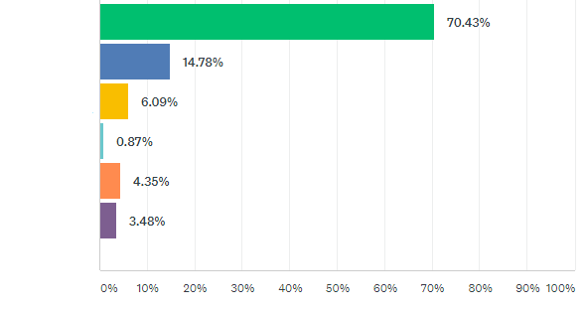
- 70% stated that they thought it was a great idea that there be a memorial for the Magdalene women on the site with 15% stating it was a good idea, 85% overall in favour.
- There was a small number who rated the idea as terrible (4% and poor (1%).

Qs. 2 At a Public Meeting the following ideas for the site were discussed. What do you think of these ideas for the Convent Lands?
The land remains in public ownership (owned by the state and not sold to the developer). The state would then develop it.
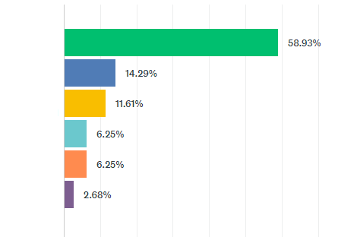
- 59% rated that the land should remain in public ownership as a great idea with an additional 14% stating it was a good idea, 73% in total.
- 6% stated it was a terrible idea and 6% also felt it was poor.

A memorial for the Magdalene Women, decided in consultation with the women
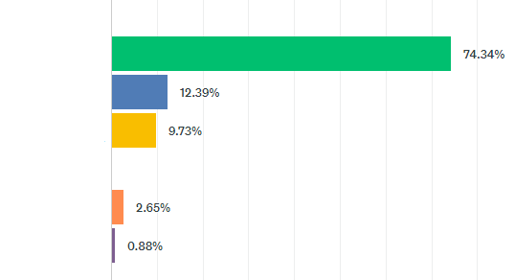
- 74% responded that this was a great idea with an additional 12% thinking it was a great idea.
- Only 3% responded negatively to the proposal.

Public Housing – a mix of affordable and social housing
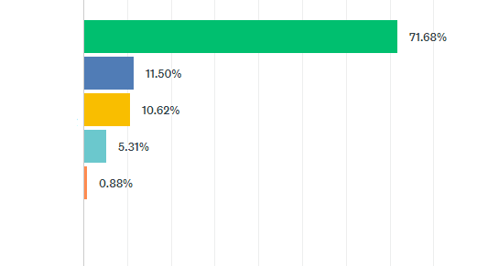
- 72% of respondents stated that public housing on the site was a great idea and 12% stated it was a good idea. 1% stated it was a terrible idea and 5% that it was poor.

There should be no student accomodation
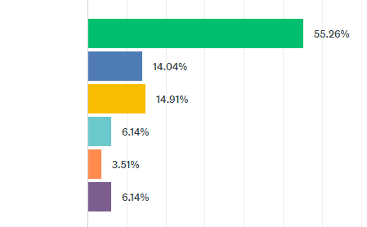
- 55% responded that there should be no student accomodation on the site. 4% responded that it was a terrible idea, therefore in support of student accomodation.
One stop shop for community use
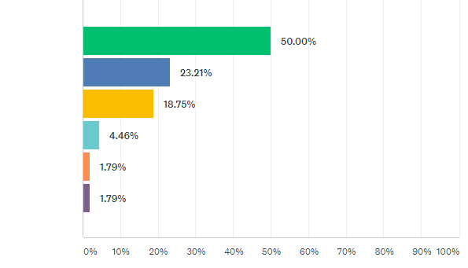
- Overall there was a positive response to this proposal with 73% responded favourably.
Overall in terms of the comments given, there is support for the site to be used for a mix of social and affordable housing with a memorial to honour the Magdalene Women.

General Comments
- I am horrified by the plans and the decision to sell it. It is steeped in a horrific part of Irish history and should be preserved.
- It should be used for the sole purpose of social housing and affordable housing only! I live only a few streets away; the area is full of families struggling to find affordable homes and rents have sky rocketed. Cinemas, galleries, hotels etc will only spike rents further, causing more suffering to the families in the area. We are a 15 minute walk from Lidl, cinemas and Henry Street Shops. We need social housing and lots of it.
- I think the land should be used for community or social housing purposes owned by the State with a memorial to the women and children who suffered there included.
- Land was given to the state. Selling would be greedy. DCC have no right to sell.
- It seems to be incredibly short sighted bordering on ridiculous that at a time of a housing crises that this land is to be used for a low budget hotel and ONLY 4 social housing units. This site, currently publicly owned in Dublin City centre is ideal for a mix of social and low cost housing. A low budget hotel will have the very minimum of jobs created in it and the handful of jobs will be low wage and transient, of no benefit to the locality. Whereas social housing and low-cost housing brings stability and community to the area.

Qs3. Ideas on how the site should be used
- I like the idea of a mix of housing, my grandchildren could live in the area.
- A park with green spaces and a playground, not have to go to Fairview for somewhere safe for them to play. Half one stop shop/community centre with social and affordable housing on top.
- This valuable resource needs to be used for the overall good of the community and integrated into the rejuvenation plan
- Social housing for families should take priority over all other considerations - with facilities for single parents, young children and community facilities for teenagers
- DCC are reneging on plans for the community; at one stage we had a new Lourdes day Care Centre, a proposed Leisure Centre including a revamped pool in old Preschool site and a community hub in old convent building. No more privatisation of the community that benefits no one except private companies.
- There are 2000 households on the waiting list in our area. We need to build homes instead of dumping families in hotels.
- If hotel goes ahead what will happen to the rest of Sean mc Dermot street?
- A full and inclusive discussion should be held with the community before any future proposal is made on this site.
- Absolute priority should be social, affordable housing, affordable rent owned by the State or trusted voluntary housing organisations.
- The land should be used to develop social housing owned 100% by the state, with some services for local community.
- Arts spaces are necessary for artists and the community as well as houses. It’s a lovely street, it needs minding, a grand boulevard.
- For the homeless people in inner city
- More sheltered accommodation for older people
- DCC build homes, affordable for first time buyers- 50/50 scheme
- Both a memorial alongside mixed tenure (affordable and social) housing would be my preference.
- Aspects of the current site should be protected, including the church and the front of the building. The site should be built to a high specification in a contemporary way to create a focal point for the area and its current problems. The home memorial close by and the Halloween festival housed on Killarney Street should be joined up the street to the Church and the Convent as a kind of centre of the NEIC village and the community garden should all be brought together.
- Due to the fact that a lot of estates and places in the area had to be blocked off and are unsightly this whole area of Sean MacDermott Street/ Killarney Streets/Rutland Street/ Buckingham Street and surrounding areas should become a kind of hub… similar to the Pearl District in Oregon.
It should be noted that not all respondents were against the proposal as evident from the responses above.
- I think just about any new 'life' being brought into the area is a good thing - a lot more pedestrian traffic
would really help to improve the area, I believe.
- A hotel might help with the anti-social.
- Jobs should be made available for local people, anything that creates employment and a mix of business that would create jobs.
- If a hotel goes on the site, we need to assure in the planning application that there is a stipulation for local labour and no zero hour contracts.
- I like the idea of a mix of housing, my grandchildren could live in the area
- Be smart. This area needs a wider mix of economic activity - give local people the opportunity for employment and chance of a better life. There are other models of development that can improve people’s lives other than black and white- 100& public or private- worth exploring further.
- They have to sell it as DCC won't do anything with it and it will be left.
- Yes to sale if informed by high quality state of the art. Urban design plan integrating with key eco-friendly urban development for the local area.
- I have mixed views, I really want to see the site developed as soon as possible, to help to regenerate the area.

Qs.4 Should our local Councillors vote to sell the land to Tokyo Hotels for development of the site?
Answer Choices |  | Responses
Yes |  | 15.89%
No |  | 84.11%

Convent Lands Survey Comments (with no editing)
- Please no more student accommodation - it's everywhere, we need homes
- A hotel might help with the anti-social.
- Jobs should be made available for local people.
- No more student accommodation, should be social housing
- If possible, mostly social housing rather than private
- Enhance the area, bring more visitors
- Land was given to the state. Selling would be greedy.
- DCC have no right to sell
- One Stop Shop for Community Use- Already done HSE
- Would like to see social and affordable housing
- This site should be used for the benefit of local people, no to private developers
- No memorial to a slave institution
- Would welcome any development
- This valuable resource needs to be used for the overall good of the community and integrated into the rejuvenation plan
- Should be a memorial for the Magdalene women
- Social housing for families should take priority over all other considerations - with facilities for single parents, young children and community facilities for
teenagers
- The building should remain as public property and should be used by the community. In my opinion all religious iconography should be removed and the
survivors should be consulted about the use of the building and their memorial.
- DCC are reneging on plans for the community; at one stage we had a new Lourdes day Care Centre, a proposed Leisure Centre including a revamped
pool in old Preschool site and a community hub in old convent building. No more privatisation of the community that benefits no one except
Private companies.
- appreciate the wider consultation
- if there’s houses built with garden I’ll take one. Good luck with what the future bring to the community ????
- Think it should be for the local community for different projects to address the ongoing problems regarding our housing issues for families who have to live
in conditions such as overcrowding give young people of the community to be independent to have their own accommodation where they can live
independent or some tenants who live in circumstances where they maybe subjected to live in fear abuse or addition where they share their living space
as a sub tenant and have no choice of getting rehomed from DCC where they are years on the waiting list
- DCC, BUILD HOUSING NOT HOTELS!
- We need public housing on Seán McDermott St.
- There are 2000 households on the waiting list in our area. We need to build homes instead of dumping families in hotels.
- Salesian fathers? A further insult to the women and children that suffered at the hands of the catholic church. They have more than enough money to house
themselves.
- We need less business, less student accommodation and more social housing
- Positive and affordable development activities for the community.
- If hotel goes ahead what will happen to the rest of Sean mc Dermot street?
- A full and inclusive discussion should be held with the community before any future proposal is made on this site. get the council to withdraw the current
proposal.
- Absolute priority should be social, affordable housing, affordable rent owned by the State or trusted voluntary housing organisations
- I think just about any new 'life' being brought into the area is a good thing - a lot more pedestrian traffic would really help to improve the area, I believe. It
- would be good to link in with other artistic Monto area businesses.
- Given the history there should be involvement whatsover by any religious order nor any use of facilities by any religious order.
- The land should be used to develop social housing owned 100% by the state, with some services for local community
- The site should firstly have the grounds exhumed to ensure there are no hidden graves. Thereon it should be used for the sole purpose of social housing
and affordable housing only! I live only a few streets away, the area is full of families struggling to find affordable homes and rents have sky rocketed.
Cinemas, galleries, hotels etc will only spike rents further, causing more suffering to the families in the area. We are a 15 minute walk from Lidl, cinemas and
Henry st. Shops. We need social housing and lots of it. Please don't slap the faces of local residents by creating a monstrosity of a useless hotel which will
help no one but private business owners. I for one know that local residents will picket and petition against any private ownership of the former laundry.
It would be wise, just and respectful to use this site to help communities directly by creating homes they can access, and yes possibly a community centre.
- Both a memorial alongside mixed tenure (affordable and social) housing would be my preference.
- A centre would be nice such as The Carmichael Centre model. To show our volunteering capacity e.g. Civil Defence and Army Reserve, Red Cross and ATD
helpers.
- Leave the people affected by the laundry decide on what type of memorial.
- I think the land should be used for community or social housing purposes owned by the State with a memorial to the women and children who suffered
there included.
- People before profit.
- Priority stays in Public Ownership - Housing a priority. A memorial could be included in any build. Enough Private student accommodation around.
- Arts spaces are necessary for artists and the community as well as houses, its a lovely street it needs minding, a grand boulevard
- if a supermarket it should have apartments above, there is a need for accommodation for single people and couples and units for small families
- The building has historic memories for the people of the NEIC. This should be considered in the light of any plans to develop the site.
- A large number of sites are currently being developed in the area and this one is special because of the special nature of peoples stories etc.
- The space should be used as a 'Community Hub' for community groups with a memorial to the Magdalene women outside.
- must be kept in public ownership and use4d for community including social housing
- I think this site should be maintained for community use
- There needs to be more consultation
- A real public and affordable housing aspect and a real ( ie a residential project needy young people in after care) memorial to those who suffered
over the years in the laundry complex
- It seems to be incredibly short sighted bordering on ridiculous that at a time of a housing crises that this land is to be used for a low budget hotel and
ONLY 4 social housing units. This site, currently publicly owned in Dublin City centre is ideal for a mix of social and low cost housing. A low budget hotel
will have the very minimum of jobs created in it and the handful of jobs will be low wage and transient, of no benefit to the locality. Whereas social housing
and low cost housing brings stability and community to the area.
- If a hotel goes on the site we need to assure in the planning application that their is a stipulation for local labour and no zero hours contracts
- This survey is very important to the community and was completed by local residents
- More housing is needed, not hotels
- Mix of business to create local jobs.
- Public land should be in public hands
- I like the idea of a mix of housing, my grandchildren could live in the area park with green spaces and a playground, not have to go to Fairview for
somewhere safe for them to play.
- Half one stop shop/community centre with social and affordable housing on top.
- For the homeless people in inner city
- Something more to keep the young kids off the streets and keeping safe
- Magdalene women memorial
- Proper Advice Centre Officers, Health Centre Disability, Easy available Community welfare office, properly staffed
- More sheltered accommodation for older people
- DCC build homes, affordable for first time buyers- 50/50 scheme
- Affordable housing for young people starting out in life
- Affordable Housing - step down housing
- Young people struggle to get on property ladder- rent too high
- Day Care centre for the elderly
- To house people (locals)
- Should be used for the people and the women
- Turned into social housing as there are a lot of families in need
- It should be used for more housing as it will bring new people to the area
- Memorial and affordable housing for young people to get on the property ladder or social housing
- The old church in the convent should be used for community hall as we don't have one in the area. Also I think the Salesian Fathers should still be
accommodated on the site
- More housing and anything that gives employment to locals
- Housing for the community.
- Accommodation is needed, employment opportunities and youth and educational projects
- housing for residents
- Like to see creative enterprise centre hub to support sme development locally and artistic creative projects
- Trade school ! i.e. Bricklayers plasterers, painters, etc
- A memorial
- Cooperative housing, community theatre space, workshops for start-up businesses
- More houses
- It should be used in collaboration with the women from the Magdalene Laundry and for the benefit of the local community.
- It should be used for the community.
- Homeless
- Be smart. This area needs a wider mix of economic activity - give local people the opportunity for employment and chance of a better life. There are
other models of development that can improve people’s lives other than black and white -100% public or private - worth exploring further.
- Families that have growing up daughters or sons who what to live independently without having to go on homeless to get accommodation or siblings
who are in positions where its unhealthy for them to share accommodation with family members because of the other persons addition or violent behaviour
- Public housing
- Social and affordable housing along with a tribute to every unfortunate lady that crossed them doors
- Social housing
- Public housing. We need housing.
- A hotel might help with the anti-social.
- Jobs should be made available for local people.
- No more student accommodation, should be social housing
- The Need to remember the terrible treatment of women in the Laundries, the Community Resource needs and the housing needs of the area all need to
be balanced.
- To me that means. A museum, community center and social and public housing should be priority or whatever best mix of the three we can get.
Hotels, car park and student accommodation should be off the table.
- more social housing, if hotel is built people driving down the street will never know that liberty house or peadar karney house exist.
- Purpose built centre for Crinan Youth project, supermarket/shops, cafe, one stop shop for community use with a small green area / tree area to sit in and
the Magdalene memorial statute could be housed there.
- Part of it being a Magdalene Laundry museum, similar to Workhouse museums elsewhere; plus theatre space/cafe/restaurant/community hub.
- Exhibition/art centre which should include a dedicated section to the history of the laundries and the involvement of the church in them.
- Public housing& good services- accessible sports facility for informal use by community/young people
- Mainly Social homes and affordable homes (not Leo's €350,000 "affordable" homes, but genuinely affordable homes that working class people can access).
- Both a memorial alongside mixed tenure (affordable and social) housing would be my preference.
- Retirement homes for elderly with own shop and meeting rooms a communal space like Newtown court in Darndale
- I think the land should be used for community or social housing purposes owned by the State with a memorial to the women and children who
suffered there included prominently.
- Some happy memories for the community and familiar need to be created at this site. Not for profit.
- social and affordable housing
- Social and affordable housing
- Housing
- Arts spaces, flats and a shop
- accommodation, one stop shop, social amenities, and family law centre
- Sensitively... and in a way which hopefully heals... and reminds us all so we never forget...
- As a community site , training for women , develop as a hub to empower local people especially young women
- Aspects of the current site should be protected, including the church and the front of the building. The site should be built to a high specification in a
contemporary way to create a focal point of hope for the area and its current problems. The home memorial close by and the Halloween festival housed on
Killarney Street should be joined up the street to the Church and the Convent as a kind of centre of the NEIC Village and the Community Garden should
all be brought together. Due to the fact that a lot of estates and places in the area had to be blocked off and are unsightly this whole area of Sean
McDermott Street/Killarney Street, Rutland Street/Buckingham Street and surrounding streets should become a kind of hub...similar to the Pearl District
in Oregan.
- developed for public housing
- It should be a memorial to the Magdalene women with a space for the Crinan project and some community activities.
- Social housing
- Profiting on a site that holds so much pain and meaning makes me very uncomfortable. The entire site should be used to mark the institutional abuse in
Ireland and create a space for healing through a museum or art project.
- Provided there is Public and affordable housing, a real memorial, community space and Crinan project I am ok re the hotel etc
- A memorial is a priority. Depending on the design, there may be land left for other purposes. I would like to see a public amenity then being prioritized.
- Mix of social and low cost housing, open plan space, with community centre and a museum to what took place at the laundry on site.
- Should be kept as a community hub with local services and in consultation with the Magdalene Women should include memorial
- Mixed housing with some commercial development. The church should be the memorial to the women and dedicated to them, an exhibition could be part
- of that dedication.
- Community use
- I think it should be used to for mixed housing.
- I think it should be exhibit the horrors that the women suffered, so we ensure to never make the same mistakes again.
- Accommodation for the community and community use space, as well as a suitable memorial for the women, good public accommodation could also be
a memorial in kind as it would have been women from communities like these who would have been imprisoned there.
- Given the history, I would like some element of it developed for use for single women, and single parent families - perhaps affordable housing for this group.
- I wouldlike to see any hotel or restaurant create local employment, and bring something postive to the community. The chapel should remain in public
ownership as a creative space. And the memorial to the women must be done in consultation with them.
- They have to sell it as DCC won't do anything with it and it will be left.
- Jobs for local people
- hopefully this consultation will give further insight ideas so a decision in the best interest of the community and inner city is made as we go forward.
- Yes to sale if informed by high quality state of the art. Urban design plan integrating with key eco friendly urban development for the local area
- I am horrified by the plans and the decision to sell it. It is steeped in a horrific part of Irish history and should be preserved.
- Explore many options. design new ones. think win-win
- yes a house with a garden for my youngest baba
- Give our own local community a choice for their future
- Public Housing for all
- Let the women and their families have a say
- Let the community vote on the issue
- Don't sell to build a hotel. We need housing. Build public housing.
- I think it is worth talking to the entire community on this and have a community plan for the site. We should look at what people need for housing,
community and memory for the laundry all together and we willing to fight together for it
- the homeless situation is a joke. tackle it head on.
- SCRAP THE WHOLE PLAN.
- I have mixed views, I really want to see the site developed as soon as possible, to help to regenerate the area.
- These buildings are iconic for all the wrong reasons. The abuse they represent should never be forgotten or forgiven, for that reason they should include a
permenant history of that abuse, not unlike Ann Franks house in Amsterdam. to do less would show disrespect the suffering of so many.
- Current plans would have a negative impact on the existing community
- The plans are insulting to the local families and communities struggling to keep roofs over their heads! We have copious hotels beside us. We need homes,
not hotels and profits for foreign investors!
- Not sure of language using wording that links future development of existing wants (e.g. Rutland Street School) to the successful sale of an unwanted project
- Let the people talk not the money.
- We have a housing crisis with more than 3k children in emergency accommodation and thousands more in unsuitable and unstable homes. Is the State
going to sell the land to a private developer to build a hotel only to then pay that hotel owner to house the homeless? Build social housing, include
community supports and services and memorialise those who suffered.
- They are disrespectful and insulting - they begger belief- they also lay bare the neoliberal ideology of the Irish state.
- the site should remain in the hands of the community
- Hotel would be NOT appropriate or desirable
- Sean McDermott Street should be a lovely place for all
- I hope something is built that has a connection to the local people and the future generations in the area other than low paid work.
- The land should not be sold to private companies, it should remain state owned
- I think this should be made in to as high quality as possible social housing and accommodate as many families/ single mothers and fathers as possible
- It is an insult to every person who is homeless or o a housing list that this site be sold to a low budget hotel chain.
- Current plans are disgraceful!
- Public land for public use
- Decisions should not be made without consultation with the community
- What do we need, HOUSING! Simple
- Some of the 2 acres for a hotel I believe, but keeping the chapel and some land back for social and affordable housing.

